TRIO survey analyses - May 2018

# Introduction

This is a report on surveys conducted after the hybrid TRIO training in May 2018. This training was conducted by Cuyahoga Community College. More infomation available here. Of the original 21 who had signed up, all but one (and, indeed, this person did not show up for the training) completed the training.

Of the 21 participants registered for the training, 18 completed the pre survey (a 86% response rate) and 10 completed the post survey (a 48% response rate).

# Institutions Represented

20 participants were involved with the March training. The locations of the institutions they represent are below.

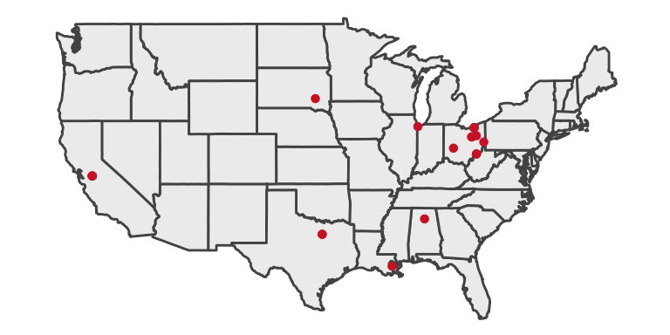

# Demographics of Training Participants

## How long have you managed the budget(s) for a Federal TRIO program at your current institution?

The average years of experience was 1.97 years.

## 

## Have you attended a similar TRIO training program in the past?

**No Maybe Yes**

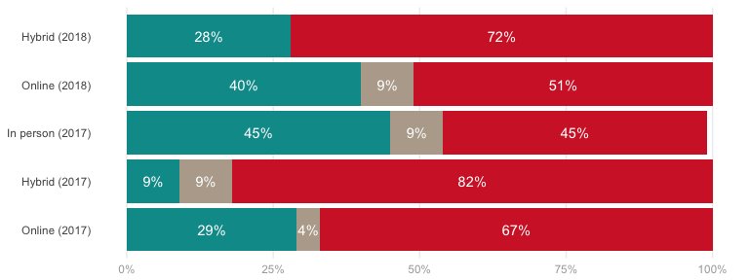

## Currently, are you one of the main budget-related decision makers at your institution?

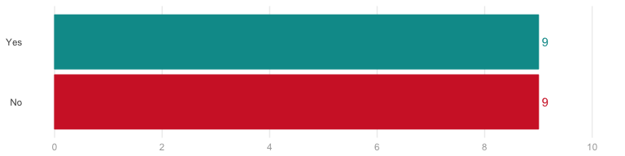

### If no, how many other staff members work in your department?

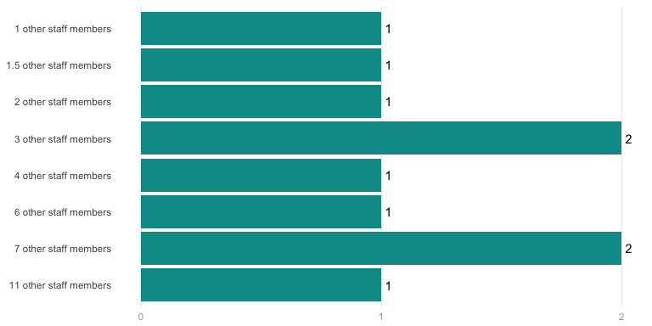

# Pre-Training

## Currently, how would you rate your levels of knowledge and understanding of the following aspects of the training you are about to receive

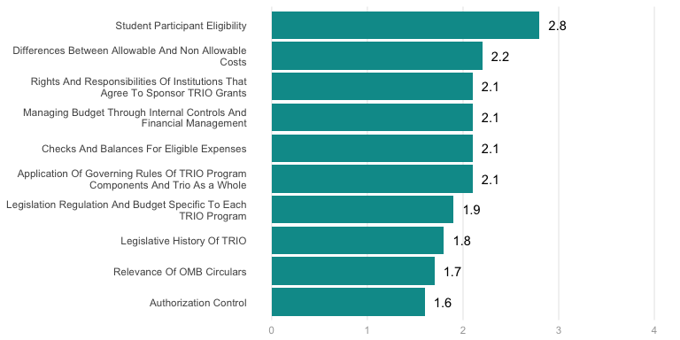

## What are some of your main expectations from the training?

* Clarity of the creating a budget; developing and planning for future services; understanding the flexibility of moving funds from different categories within the annual budget; How to prepare a annual budget and update services; Helpful technologies (expenses) to improve efficiency and the participant experience
* Greater understanding of what I can and can’t do with federal dollars. 2) Greater understanding of the laws related to spending in a TRiO program. 3) strategies, tips, and resources to better understand how to budget, where to allocate mney, and how to be a more prudent steward of federal dollars.
* Mainly, to get a refresher because I attended a face to face when I first started in my role, however I was new to the grant world. So much information has been disseminated to me in this past year, I feel it necessary to get this one again for clarification and refreshing.
* To have a better understanding how we (director and accounts, etc) can work as a team to insure the success of the program. Learn more about the different regulations that guide our programs.
* Budget, allowable expenses, new ideas on how we can utilize our funds to serve participants, training for peer mentors, want to check that we are doing things right.
* I am particularly interested in getting a better understanding of some of our allowable/not allowable costs.
* Strengthen knowledge base, discover best practices, and revisit preferred language for budget requests
* A better understanding of how the budget impacts my program. Allowable expenses,
* To get a better understanding of how we should be spending our money.
* Get a better understanding of TRIO specific budget mandates
* To gain a better understanding of how the program works.
* To learn more about budgeting aspects of TRIO programs.
* To learn more about budgeting for Upward Bound
* To hear recent updates.
* To get any updates
* Context

## What are some of the challenges that your institution currently faces as related to budget management in a Federal TRIO program?

* My university hosts 5 TRIO programs (1 UB, 1 McNair, 1 SSS, & 2 ETS), not all are regulated similarly. I want to strengthen my authority with regulations and budget specific items related to the Student Support Services grant.
* Staff turnover; Not serving non-eligible, (non-TRIO) students at a small, private university; understanding food expenses for educational activities;
* The current political atmospheres desire to reduce federal government expenses and impact on higher education.
* New Program Manager (me) who was originally the Academic Advisor with little budgetary experience.
* Check and balance, what oversees what with regards to federal vs. Institutional regulations.
* Institution pays low salary/wages, so we have much more money to budget and spend.
* Time, not sufficient as the Director also has role of counselor.
* Having a different fiscal year than our institution.
* I cannot think of anything at the moment.
* We currently have 3 budget years open.
* Underspending due to staff turnover
* Changes in Staff
* Purchasing

## Additional questions/comments regarding the training you are about to receive.

* What are some tips to learning the CFR and all that? Or is it good to just keep the updated list on hand and refer to it at all times?
* Looking for clarity and confidence, not more confusion?
* Cost-sharing and working with other TRiO programs.

# Course Ratings

## How would you rate the quality of the following course, topic or content area?

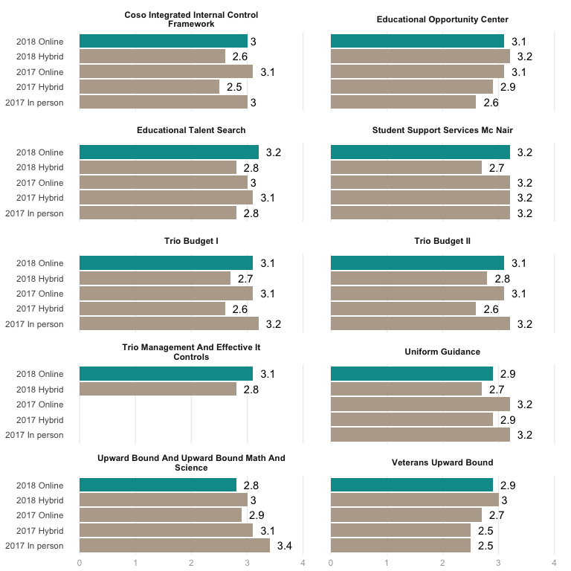

## 

## If you rated low or medium on any of the items above, please mention why.

* I found the coso training confusing at times, and dry at others. The content is hard to understand for me.
* A lot of information was covered, somethings weren’t explained very well.
* Information covered is very broad and general. Need more examples/cases.
* Quality of the presenter.
* Delivery of information

## To what extent were your general expectations of the training met?

* Somewhat met - I would prefer a LIVE trainer rather than watching videos of training (Damon Hacker and Plante Moran, LLC)
* This was my first TRiO Training, so I wasn’t sure what to expect, but it was very informative.
* Training was informative and provided a rational for why some decisions are made.
* Consistent with expectations.
* My expectations were met
* Low to Medium level
* I didn’t have any.
* Very well met.

## Please mention three (3) main take aways from the overall training

* My position is not as heavily involved with the budget, but I felt the conference emphasized why we do what we do, why we do it the way we do, and where we can refer for more information. The information about time and effort reporting was especially eye-opening. Although we follow this process, it was shocking to see the fees for non-compliance for universities who have violated the policy. Covering the allowable and nonallowables was also helpful to me. In addition, I enjoyed that we did breakouts by program - our group had a great discussion about expenses and procedures.
* That we are ahead of the curve, that COSO and UGG are overwhelming to the novice grant manager, and that people who excel at one thing don’t necessarily excel at another, e.g. Excellent accountants/auditors don’t necessarily make excellent trainers.
* 1)The importance of the yearly budget that is submitted to my Federal Program Officer 2) The importance of a good relationship with my Federal Program Officer 3) The importance of good internal controls.
* There is so much to know. There are time I wish for more direct details. The trainers were very welcoming, supportive and knowledgeable.
* Importance of knowing how you fit in. 2 Making sure that funds are allocated properly. 3. How to find the information for legislative.
* The allowable and Unallowable costs for Upward Bound. Internal Controls. What an audit actually means
* Read your grant, Keep current with regulations, provide a rational for expenses
* Nothing stands out. Share a good template sample of Budget Tracking excel.
* Check and balances is key. Know your regs, Importance of cyber security
* Time and Effort, budgets and audit information

# Satisfaction with Aspects of the Training

## Please rate the following aspects of the overall training

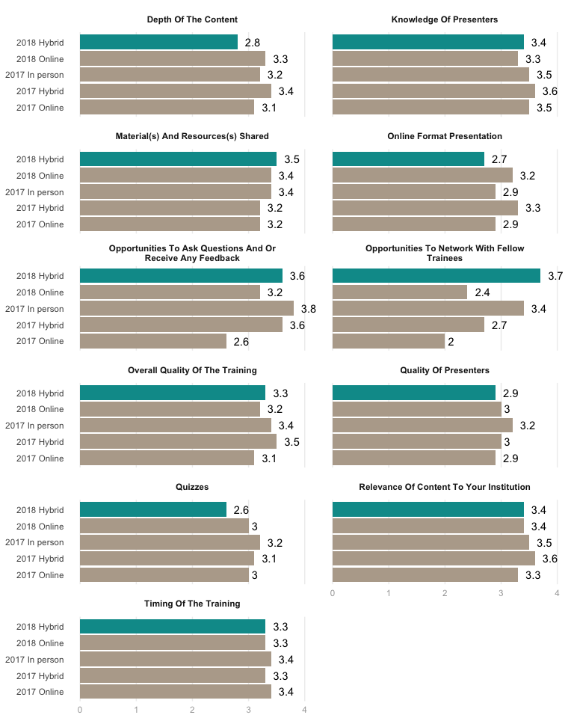

## If you rated low or medium, please mention why.

* The benefits of having a live speaker are being able to ask questions directly and more lively engagement. I found the videos to be boring and slightly disappointing although the organizers were delightful and generous hosts.
* Last presenter was very monotone and made it hard to concentrate on info he was sharing.
* The script and the PPT pages seemed to be on different tracks at times.
* Presenters mostly read from the presentation slides.

# Knowledge Growth

Below are the results for the pre and post self-assessments of participant knowledge in various areas. The larger the gap between the red and blue dots, the greater the knowledge growth that occured for participants.

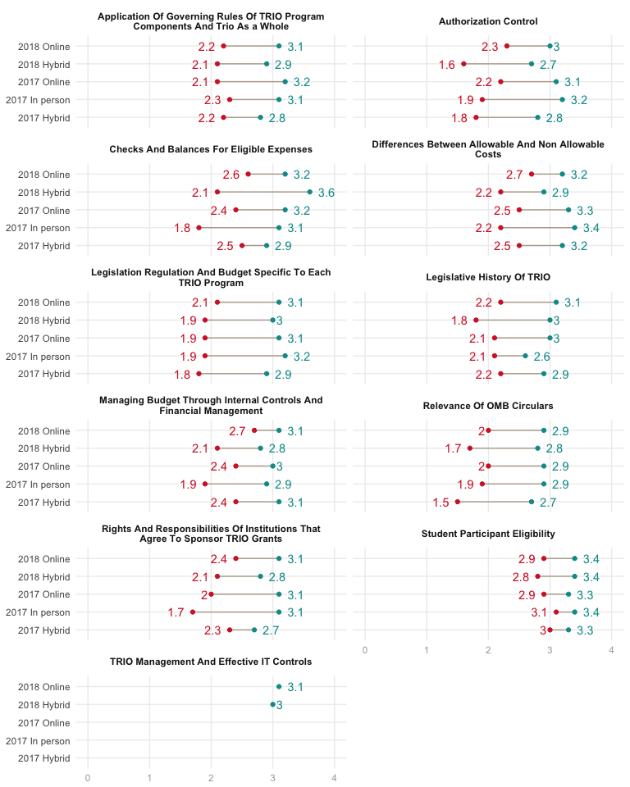

# General Feedback

## Are there any additional topic(s) that could be added in future training(s)?

* I would have liked to have heard about TRIO current events/in the news… Future of Trio
* More on audits

## Would you like a follow-up training session on the same topic(s)?

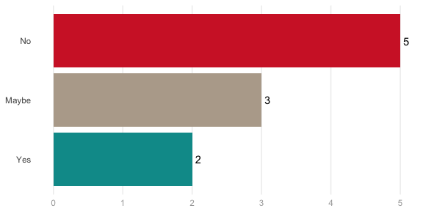

## Will you recommend this training to your colleague(s)?

